**Interpreting Prehistoric Cave Art**

P1 The Upper Paleolithic period began about 45,000 B.C. It is from this period, in several caves located in Europe, that archaeologists have discovered remarkable examples of prehistoric art. **One of the early interpretations** of cave art was that it was “art for the sake of art," much as we today might go to a museum to see the skills of artists. This is a Western-culture-centered interpretation, **however, and some would argue that** there might be other, context-specific interpretations that are more suitable. The location of this art deep within dark caves, in which small flickering lamps would only reveal small portions of painted walls, also **does not seem to fit with** an interpretation of prehistoric “art galleries."

1. According to paragraph 1, which TWO of the following could explain why the **"art for the sake of art"** interpretation of cave art may **not be accurate**? To receive credit, you must select TWO answers.
2. The narrow cultural basis of that interpretation
3. The relatively small number of surviving images
4. The different levels of skill of individual cave artists
5. The absence of sufficient lighting to permit proper viewing of the art

* **art for the sake of art** / Art for art’s sake 艺术至上主义
* flicker
* fit with

P2 **Another early interpretation** was based on the fact that most of the images are animals, and the majority of these, such as horses and bison, were hunted for food. This viewpoint became known as the "hunting magic" explanation. The drawing of the animals was interpreted as a way to magically ensure that an upcoming hunt would be successful. The hunting-magic interpretation has much appeal because we know that hunting was an important part of daily life during this period. And, in direct contrast to the art-for-art's-sake explanation, the practice of these “rituals" deep within caves suggests that not everyone participated. **There are many nonhunting images in the caves, however, that do not support** this explanation, such as geometric shapes and human figures.

1. According to paragraph 2, which of the following challenges the view that cave art was intended to ensure the successful hunting of animals?
2. Most of the animals shown in cave art were not hunted for food.
3. Non-hunters as well as hunters created images in the caves.
4. Cave art is found deep within caves that probably were hard for most hunters to reach.
5. Cave art includes many images that do not show hunters or animals.

* Interpretation/ interpret
* Ensure
* Upcoming/ incoming/ imminent
* Appeal/ charm n appeal to= attract v
* In contrast to = as opposed to
* Practice 做法

P3 In an effort to include all the types of images in Upper Paleolithic cave art in a comprehensive interpretation, some researchers turned to aspects of how the human mind works during altered states of consciousness and what images the mind “sees" during different phases of altered states. This explanation is called “entoptic phenomena," and it argues that all modern human brains experience the same sets of visual images in the same progression. **For example**, during the **first** stage it is common to see **geometric patterns**; during the **second** stage, the brain begins to associate various geometric designs with **real objects**; and during the **third** stage, the brain sees **actual animals, people, and monsters**. Altered states can be achieved in many ways-drugs, intense dancing, sitting in absolute darkness as in a deep cave-and the entoptic-phenomena interpretation argues that cave-art images represent the "visions" seen during these experiences.

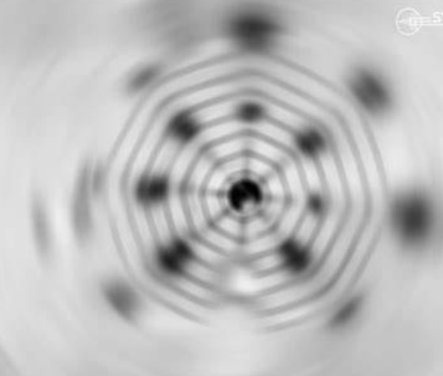

1. Which of the sentences below best expresses the essential information in the highlighted sentence in the passage? Incorrect choices change the meaning in important ways or leave out essential information.
2. Some researchers studied the different ways in which looking at cave art alters the consciousness of the people who look at it.
3. In developing an interpretation that includes all types of cave art, some researchers considered how and what the human mind sees during altered states of consciousness.
4. Interpretations of cave art are different according to which state of consciousness the human mind is in at the time the image is being viewed.
5. ln seeking to interpret how the human mind works during altered states of consciousness, some researchers examined what people see when they look at various cave-art images.
6. The word "progression" in the passage is closest in meaning to
7. location
8. way
9. period of time
10. order
11. 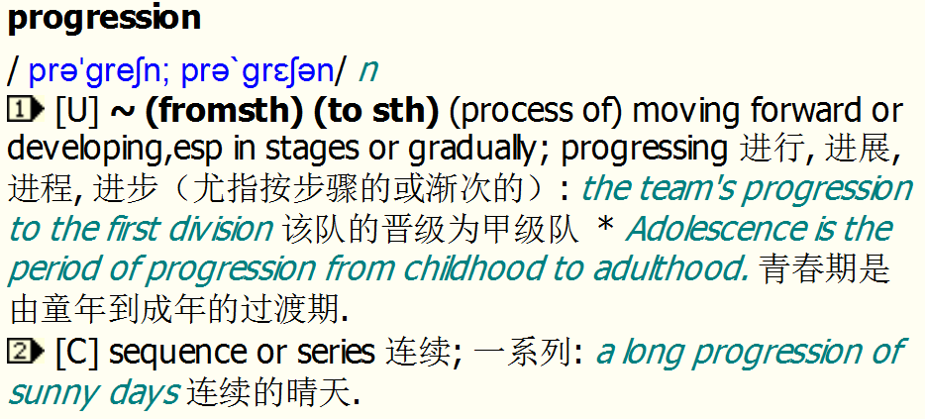
12. Which of the following best describes the entoptic-phenomena interpretation of cave-art images, as discussed in paragraph 3?
13. Cave artists first produced geometric patterns and only later produced images of animals, people, and monsters.
14. Cave art depicts images that the human brain sees as it passes through the stages of altered states of consciousness.
15. By closely looking at a set of cave-art images over a long period of time, a person can enter an altered state of consciousness.
16. The purpose of much of cave art was to show people engaging in activities that led to altered states of consciousness.

* In an effort to do sth./ With a view to doing sth.
* Altered states vs. altering states
* Consciousness/ awareness be conscious/ aware of

Entoptic ent+ optic

* Progression
* Phenomenon phenomenal

P4**Other explanations** focus more on the use of cave art as a form of **communication**. That is, its presence and the types of images were used to establish social identities and perhaps as territorial markers. Communication as an explanation is based on identifying different styles that represent different groups of people and is a key element at aggregation sites, places where these people came together at certain times. Communication **also** is seen as adaptive because it enhances the survival of groups using social networks or alliances. The abundance of cave art in France and Spain, particularly during the Late Upper Paleolithic, is thought to be one outcome of the dense packing of people as they moved south to escape the harshest conditions of the extreme cold of the glacial maximum of the last ice age. Art was used to form alliances and thus resolve disputes about resources between groups who could not easily move away because of the close presence of many groups and the inhospitable nature of more northern areas in Europe.

* Aggregation aggregate/ gather / convene/ assemble
* Marker
* Alliance ally be allied to
* Later Upper Paleolithic
* Harsh harsh weather harsh personality be harsh on oneself
* Inhospitable hospitable

1. According to the interpretation discussed in paragraph 4, cave art may have performed all of the following functions EXCEPT
2. marking people's territories
3. ~~encouraging~~ people to move south
4. helping to form alliances with other groups
5. resolving conflicts over resources
6. Paragraph 4 suggests that which of the following led to high population density in France and Spain during the Late Upper Paleolithic?
7. The availability of a large variety of animal species that could be hunted for food
8. The long-established social networks in those regions
9. The relatively warm temperatures in France and Spain compared to other areas in Europe
10. The overcrowding in areas to the north

P5 In recent years, accumulating evidence suggests that Upper Paleolithic people created wall art not only in relatively inaccessible caves, but also in the rock shelters where they lived. Like Later Stone Age rock shelters in Africa, those of the Upper Paleolithic in Europe were exposed to sun, rain, and other weather, and most of the art present in these locales has long since disappeared. The traces we do have, however, suggest that wall art was a much more common feature of daily life than the art (present deep in caves) might suggest[句子分析]. And, if wall art was much more widespread and was typical of people's living sites, then single-cause explanations for wall art, especially those that are based in part（） on its inaccessibility in deep caves, seem less likely to be accurate models for all Upper Paleolithic wall art.

Accumulate

Inaccessible accessible inaccessibility accessibility access have access to

Shelter n./ v. shelter sb. From = protect sb. From= shield sb. From

Be exposed to exposure

Locale = locality= site= venue

In part= partially e.g. 他的成果部分归功于他的合理时间规划。

1. Why does the author provide the information that wall art was created “not only in relatively inaccessible caves, but also in the rock shelters where they lived"?
2. To suggest that recent methods of accumulating evidence about cave art are more effective than earlier techniques
3. To compare the types of art in rock shelters in Europe to the types of art in African rock shelters
4. To argue that the purposes of wall art cannot be understood solely by its inaccessible location in deep caves
5. To explain why most of the wall art we still have is cave art rather than art from rock shelters
6. Look at the four squares[ ] that indicate where the following sentence could be added to the passage. Where would the sentence best fit?

**These findings raised the question of why the art began.**

The Upper Paleolithic period began about 45,000 B.C. It is from this period, in several caves located in Europe, that archaeologists have discovered remarkable examples of prehistoric art. ⬛One of the early interpretations of cave art was that it was “art for the sake of art," much as we today might go to a museum to see the skills of artists. ⬛ This is a Western-culture-centered interpretation, however, and some would argue that there might be other, context-specific interpretations that are more suitable. ⬛The location of this art deep within dark caves, in which small flickering lamps would only reveal small portions of painted walls, also does not seem to fit with an interpretation of prehistoric “art galleries." ⬛

1. **Archaeologists have attempted to understand why prehistoric people created art on the walls of caves.**
2. Some early archaeologists believed that cave art may have been related to hunting as opposed to having been created purely for enjoyment of the art itself.
3. Some researchers consider that the art may reflect visions experienced by their creators during altered states of consciousness.
4. Art may have been more common in people's everyday lives than was previously thought, perhaps establishing group identities that allowed communication both within and across groups of people.
5. The fact that ~~only some people participated~~ in cave rituals suggests that cave art was ~~created for the~~ **~~personal satisfaction~~** of the artists themselves.
6. By studying cave art, scientists ~~have developed a~~ **~~better~~** ~~understanding~~ of how the human mind reacts to images that people look at during changing states of consciousness.
7. The idea that wall art functioned as （语法分析）an aid in ~~hunting~~ is supported by both research into wall art in caves ~~and~~ into wall art found in the sites where people lived.